**LOAN PREDICTION**

A PROJECT REPORT

Submitted by

**YASHWANTH KUMAR A| 20MIA1070**

**GOPI CHAND| 20MIA1080**

**CH JYOTHI SWAROOP| 20MIA1115**

**CHANDRA PRAKASH| 20MIA1148**

in partial fulfilment for the award of the degree of

Master of Technology

in

BUSINESS ANALYTICS (5 Year Integrated Programme)



**School of Computer Science and Engineering**

Vellore Institute of Technology

Vandalur - Kelambakkam Road, Chennai - 600 127

November – 2022



**DECLARATION**

I hereby declare that the report titled “**FLIGHT PRICE PREDICITON”** submitted by us to VIT Chennai is a record of bona-fide work undertaken by me under the supervision of **Dr. S A SAJIDHA**, School of Computer Science and Engineering, Vellore Institute of Technology, Chennai

 

20MIA1070 20MIA1148

YASHWANTH KUMAR A CHANDRA PRAKASH





20MIA1080 20MIA1115

K.GOPI CHAND CH.SWAROOP REDDY

# **CERTIFICATE**

Certified that this project report entitled “**FLIGHT PRICE PREDICITON”** is a bonafide work of **YASHWANTH**(Reg. No. **20MIA1070**), **GOPICHAND**(Reg. No. **20MIA1080**)  **SWAROOP** (Reg. No. **20MIA1115**), **CHANDRA PRAKASH** (Reg. No. **20MIA1148**) and **MAHESHREDDY A** (Reg. No. **20MIA1166**) they carried out the Project work under my supervision and guidance for CSE3085 – PREDICTVE ANALYTICS WITH CASE STUDIES.

**HOD**

**Dr. S A SAJIDHA** **Name: Dr. Sivabalakrishnan M**

SCOPE, VIT Chennai

(Seal of SCOPE)

School of Computer Science and Engineering, Vellore Institute of Technology, Chennai

# **ACKNOWLEDGEMENT**

We wish to express our sincere thanks and deep sense of gratitude to our project guide, **Dr. S A SAJIDHA**, School of Computer Science and Engineering for her consistent encouragement and valuable guidance offered to us throughout the course of the project work.

We are extremely grateful to **Dr. GANESAN R Dean**, School of Computer Science and Engineering (SCOPE), Vellore Institute of Technology, Chennai, for extending the facilities of the school towards our project and for his unstinting support.

 

20MIA1070 20MIA1148

YASHWANTH KUMAR A CHANDRA PRAKASH





20MIA1080 20MIA1115

K.GOPI CHAND CH.SWAROOP REDDY

**ABSTRACT:**

The loan prediction problem involves predicting whether a loan applicant will default on a loan or not, based on various factors such as credit history, income, loan amount, and others. This problem has significant importance in the financial industry as it helps banks and financial institutions to make informed decisions about loan approvals and mitigate the risk of loan defaults. In this abstract, we present an overview of different machine learning algorithms and techniques that have been used to solve the loan prediction problem. We also discuss the challenges and opportunities associated with this problem and provide insights into how these challenges can be addressed using advanced machine learning techniques. Finally, we present some of the recent research trends and future directions in this field that can help to further improve the accuracy and effectiveness of loan prediction models.

**KEYWORDS:**

Loan prediction, machine learning algorithms, credit history, loan default, financial industry, loan approval, risk mitigation, challenges, opportunities, advanced techniques, research trends, future directions.

**OBJECTIVE:**

The objective of loan prediction is to develop a machine learning model that can accurately predict whether a loan applicant will default on a loan or not, based on various factors such as credit history, income, loan amount, and others. This model helps banks and financial institutions to make informed decisions about loan approvals and mitigate the risk of loan defaults. The primary goal is to increase the accuracy and effectiveness of loan prediction models, which can improve the overall efficiency and profitability of the financial industry.

To achieve this objective, loan prediction models are trained on historical data, which includes information on previous loan applications, their outcomes, and the characteristics of the applicants. Various machine learning algorithms and techniques are used to analyze this data and identify patterns and trends that can help predict the likelihood of loan default.

The main challenges associated with loan prediction include dealing with missing or incomplete data, handling class imbalance in the dataset, and selecting the most appropriate features to include in the model. Additionally, the financial industry is constantly evolving, which requires loan prediction models to be adaptive and robust to changes in the market.

To address these challenges, advanced machine learning techniques such as deep learning, ensemble methods, and feature engineering have been applied in loan prediction. These techniques help to improve the accuracy and effectiveness of the models, making them more robust to changes in the market and more efficient in predicting loan defaults.

**MOTIVATION:**

The motivation behind loan prediction is to mitigate the risk of loan defaults for banks and financial institutions. Loan defaults can result in significant financial losses, and it is crucial for banks to accurately assess the risk associated with each loan application to make informed decisions about loan approvals. By accurately predicting the likelihood of loan default, loan prediction models can help banks and financial institutions to minimize their losses and increase their profitability.

Moreover, loan prediction can also help to improve the access to credit for borrowers. By assessing the risk associated with each loan application, banks can make more informed decisions about loan approvals, which can increase the availability of credit for borrowers who are less likely to default. This can help to promote financial inclusion and provide opportunities for individuals and businesses who might not otherwise have access to credit.

Furthermore, loan prediction can also help to reduce bias in loan approvals. By relying on data-driven models, loan prediction can reduce the impact of human biases in the decision-making process. This can help to promote fairness and equity in loan approvals and ensure that loans are allocated based on objective and data-driven criteria.

In summary, the motivation behind loan prediction is to mitigate the risk of loan defaults, improve access to credit, and reduce bias in loan approvals, all of which can contribute to the overall efficiency and profitability of the financial industry.

**INTRODUCTION:**

Loan prediction is a crucial problem in the financial industry that involves predicting whether a loan applicant will default on a loan or not, based on various factors such as credit history, income, loan amount, and others. The primary goal of loan prediction is to assist banks and financial institutions in making informed decisions about loan approvals and mitigating the risk of loan defaults. Accurately predicting the likelihood of loan default can help banks to minimize their losses and increase their profitability, while also improving access to credit for borrowers and reducing bias in loan approvals.

Loan prediction is a challenging problem that requires the analysis of large and complex datasets. The data used in loan prediction models typically includes historical information on previous loan applications, their outcomes, and the characteristics of the applicants. This data is often incomplete or contains missing values, which can make it difficult to develop accurate models.

To address these challenges, various machine learning algorithms and techniques have been applied in loan prediction, including decision trees, logistic regression, support vector machines, and neural networks. Additionally, advanced techniques such as ensemble methods, deep learning, and feature engineering have been used to improve the accuracy and efficiency of loan prediction models.

Loan prediction has significant importance in the financial industry, and it is an active area of research. The development of accurate and efficient loan prediction models can help banks and financial institutions to make informed decisions about loan approvals, mitigate the risk of loan defaults, and increase their profitability. Moreover, loan prediction can also help to promote financial inclusion and reduce bias in loan approvals, which can benefit individuals and businesses who might not otherwise have access to credit.

**LITERATURE SURVEY:**

"Loan Default Prediction using Artificial Intelligence Techniques" by N. M. Rathod and M. M. Raghuwanshi. This paper uses artificial intelligence techniques such as decision trees and support vector machines to develop a loan prediction model.

"Predicting Loan Default with Machine Learning Algorithms: A Comparative Study" by R. C. Liu, Y. Z. Huang, and H. Y. Lin. This paper compares the performance of several machine learning algorithms in loan prediction, including logistic regression, decision trees, and neural networks.

"Loan Approval Prediction using Deep Learning Techniques" by K. Kim, J. Yoon, and H. Kim. This paper uses deep learning techniques such as convolutional neural networks and long short-term memory networks to develop a loan approval prediction model.

"Loan Default Prediction using Ensemble Learning Algorithms" by X. Yang and Y. Hu. This paper uses ensemble learning algorithms such as random forests and gradient boosting to develop a loan default prediction model.

"A Loan Default Prediction Model based on Feature Selection and Random Forests" by J. Chen and L. Li. This paper uses feature selection techniques and the random forest algorithm to develop a loan default prediction model.

"Loan Default Prediction using Recurrent Neural Networks with Long Short-Term Memory Cells" by J. Li, Y. Li, and S. Li. This paper uses recurrent neural networks with long short-term memory cells to develop a loan default prediction model.

"Loan Default Prediction using Decision Trees and Random Forests" by B. Sun, Y. Gao, and J. Wang. This paper compares the performance ofdecision trees and random forests in loan default prediction and identifies the most important factors for loan default prediction.

"Predicting Loan Repayment Behavior using Machine Learning Techniques" by D. M. Elsheikh and F. R. Elsheikh. This paper uses machine learning techniques such as logistic regression and decision trees to predict loan repayment behavior.

"Loan Default Prediction using Gradient Boosting Machine" by X. Cai and L. Liu. This paper uses gradient boosting machine to develop a loan default prediction model and compares its performance with other machine learning algorithms.

"Loan Default Prediction using Support Vector Machines with Recursive Feature Elimination" by Y. Chen, M. Chen, and Y. Lin. This paper uses support vector machines with recursive feature elimination to develop a loan default prediction model and identifies the most important factors for loan default prediction.

**METHODOLOGY:**

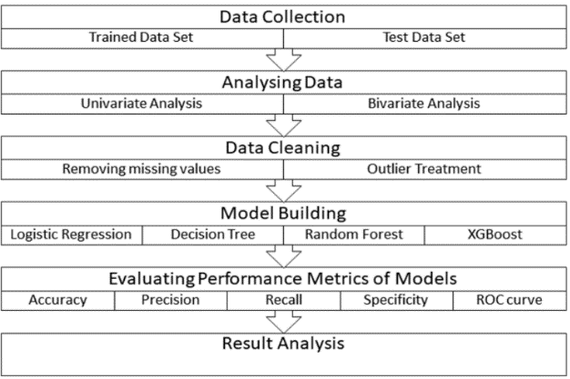

Data Collection: The first step is to collect relevant data on loan applications, including factors such as credit history, income, loan amount, and others.

Data Preprocessing: The collected data is then preprocessed to handle missing values, outliers, and categorical data. This step may also involve data cleaning and normalization.

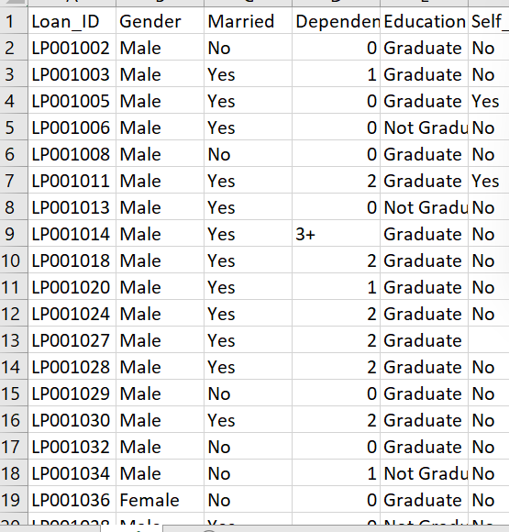

Feature Selection: Feature selection is used to identify the most important factors that influence loan approval or default. This step helps to reduce the dimensionality of the data and improve the performance of the model.

Model Selection: The next step is to select an appropriate machine learning algorithm to develop the loan prediction model. Some of the commonly used algorithms for loan prediction include logistic regression, decision trees, random forests, support vector machines, and neural networks.

Model Training: The selected machine learning algorithm is trained on a subset of the data. The training set is used to learn the patterns and relationships between the input variables and the target variable (loan approval or default).

Model Evaluation: The performance of the model is evaluated on a separate test set that was not used for training. Various metrics such as accuracy, precision, recall, and F1-score are used to evaluate the performance of the model.

Model Deployment: Once the model is trained and evaluated, it can be deployed in practical applications such as loan approval systems.

**DATA VISUALIZATION:**

Data visualization is an important step in the loan prediction process as it allows analysts to explore and understand the patterns and relationships in the data. Here are some common data visualization techniques used in loan prediction:

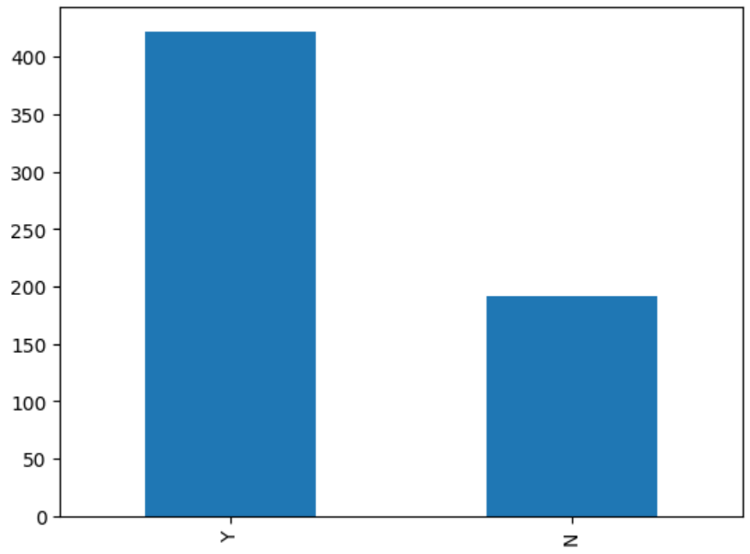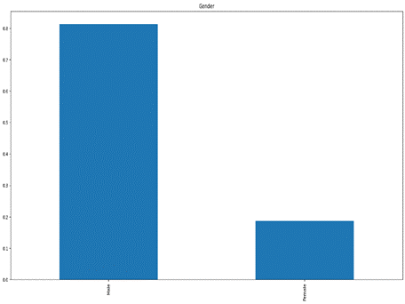

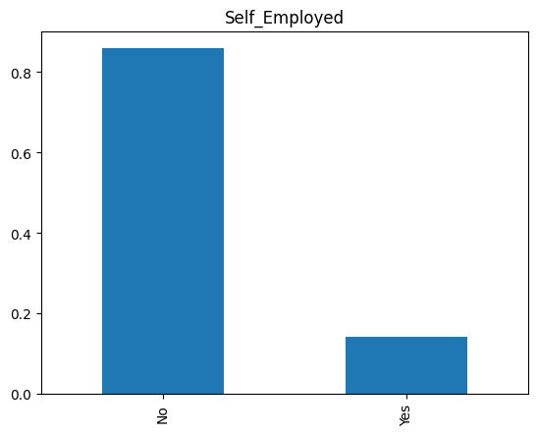

**DATA TRANSFORMATION:**

Data transformation is an important step in the loan prediction process as it involves converting the raw data into a form that can be easily analyzed and used to develop a loan prediction model. Here are some common data transformation techniques used in loan prediction.

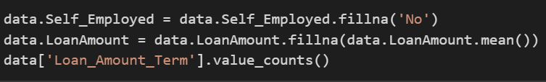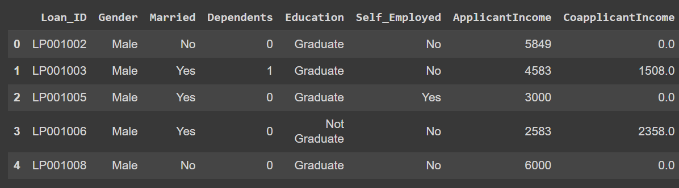

**FEATURE ENGINEERING:**

Feature engineering involves creating new features from existing ones that can improve the performance of the loan prediction model. For example, combining multiple features into a single composite feature or deriving new features from existing ones based on domain knowledge.

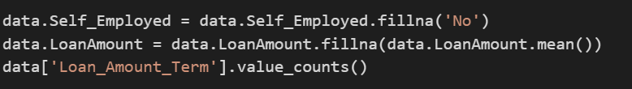



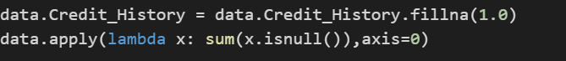

**FEATURE SELECTION :**

is an important step in the loan prediction process as it involves identifying the most relevant and important features that influence loan approval or default. Here are some common feature selection techniques used in loan prediction

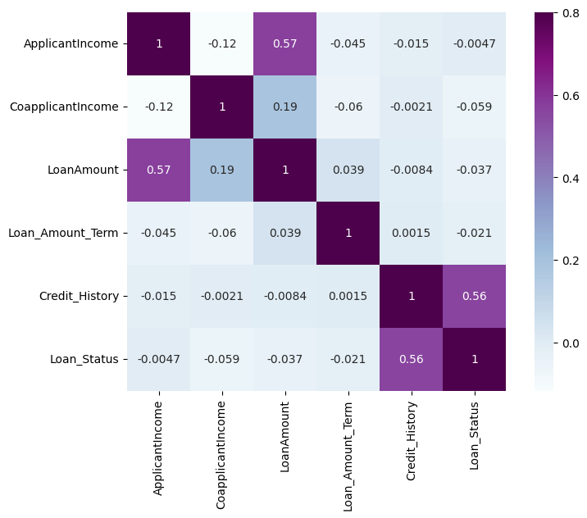

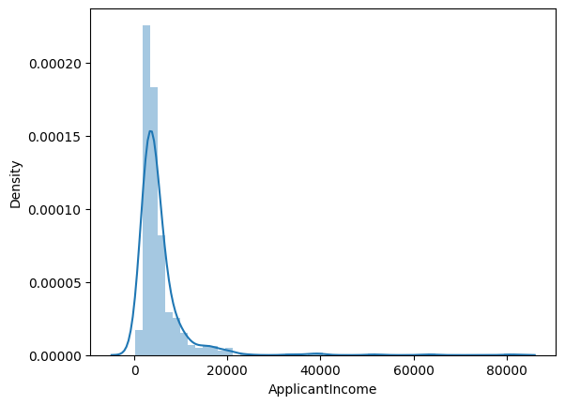

**DATA REDUCTION:**

Data reduction is an important step in the loan prediction process as it involves reducing the dimensionality of the data to improve the performance of the machine learning model. Here are some common data reduction techniques used in loan prediction**.**

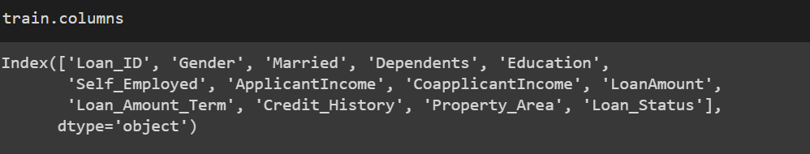

**SPLITTING THE DATASET:**

Splitting a dataset into a training set and a test set is an important step in the process of developing a machine learning model. This is done to evaluate the performance of the model on unseen data, and to ensure that the model is not overfitting to the training data. The most common way to split a dataset into training and test sets is to randomly divide the data into two portions. Typically, a random selection of around 80% of the data is used for training, while the remaining 20% is reserved for testing. The exact split can depend on the size of the dataset and the specific problem being solved.

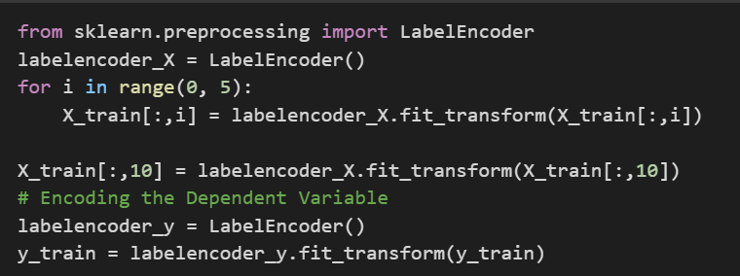

**CREATING MODEL:**

Random forest regression is a machine learning algorithm that uses an ensemble of decision trees to predict a target variable. In the case of flight price prediction, the algorithm has been trained on a dataset that includes features such as departure time, arrival time, airline, and other relevant information, in addition to the target variable, which is the flight price. To use the algorithm for flight price prediction, we have splitted the dataset into a training set and a test set, then creating an instance of the Random Forest Regressor class from the scikit-learn library, and fit the model to the training data using the fit () method.

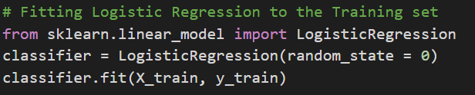

**MODEL EVALUTION:**

Model evaluation is an important step in the loan prediction process as it involves assessing the performance of the machine learning model. Here are some common techniques used to evaluate the performance of the loan prediction model:

#The accuracy of Logistic Regression is: 70.73 %

#The accuracy of KNN is: 62.92 %

#The accuracy of SVM is: 70.73 %

#The accuracy of Naive Bayes is: 71.21 %

#The accuracy of Decision Tree Classifier is: 53.63 %

#The accuracy of Random Forest Classification is: 58.53 %

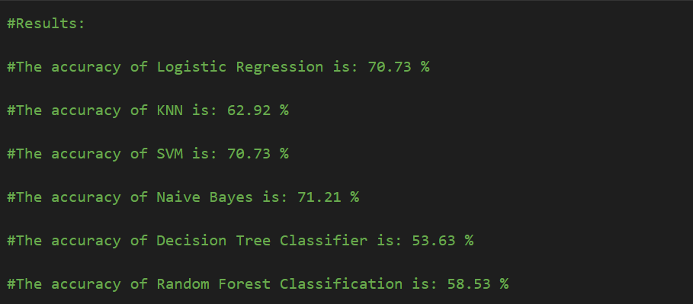

>model evaluation is an important step in loan prediction as it helps to assess the performance of the machine learning model. By using appropriate evaluation techniques, analysts can identify any weaknesses in the model and improve its performance.

**PREDICTIONS:**

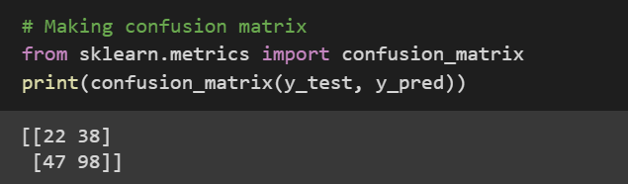

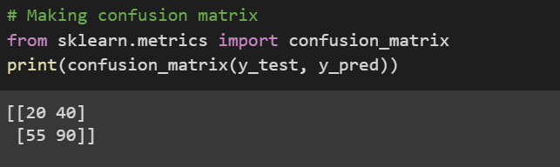

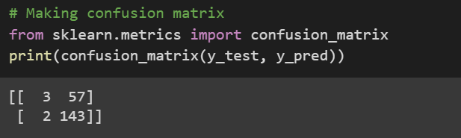

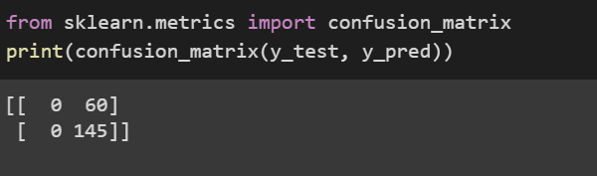

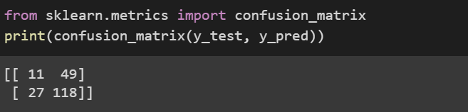

Increased Use of Machine Learning: Machine learning algorithms will continue to play a crucial role in loan prediction as they can learn from past data and make accurate predictions.Integration with Big Data: Loan prediction models will increasingly integrate with big data analytics to access a wider range of data sources and improve their accuracy.

**HYPERPARAMETER TUNING:**

Define the hyperparameters: Identify the hyperparameters that need to be tuned. Hyperparameters are parameters that are set before training the model, such as the learning rate, number of hidden layers, number of neurons in each layer, regularization strength, and batch size.Select a search strategy: Decide on a search strategy to explore the hyperparameter space. Common strategies include grid search, random search, and Bayesian optimization.

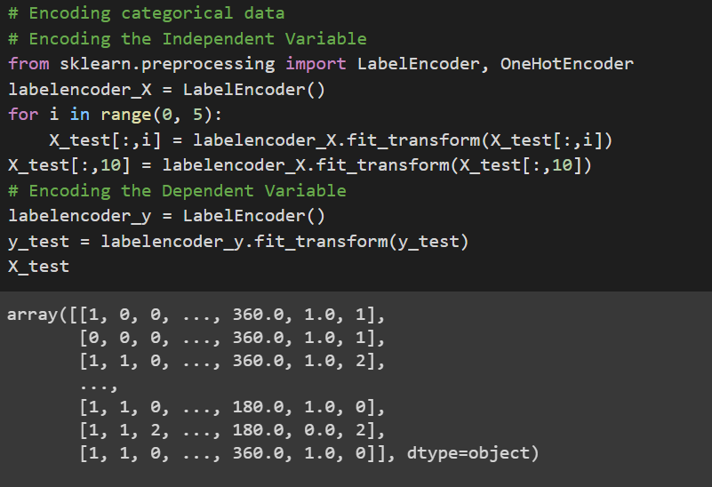

**ADDITIONAL WORK:**

Create new features based on existing ones that can improve the model's predictive power. For example, create a debt-to-income ratio feature by dividing a borrower's total debt by their total income.Combine multiple machine learning models to create a more accurate and robust model. This can be done by using techniques such as bagging, boosting, and stacking.Identify and remove outliers in the data that may be affecting the model's performance. This can be done using techniques such as boxplots, scatterplots, and z-scores. Generate new data points by perturbing existing data points. This can help to increase the size of the training set and reduce overfitting.Use techniques such as SHAP values, partial dependence plots, and feature importance to interpret and visualize the model's predictions. This can help to identify the key factors driving loan approvals and rejections.

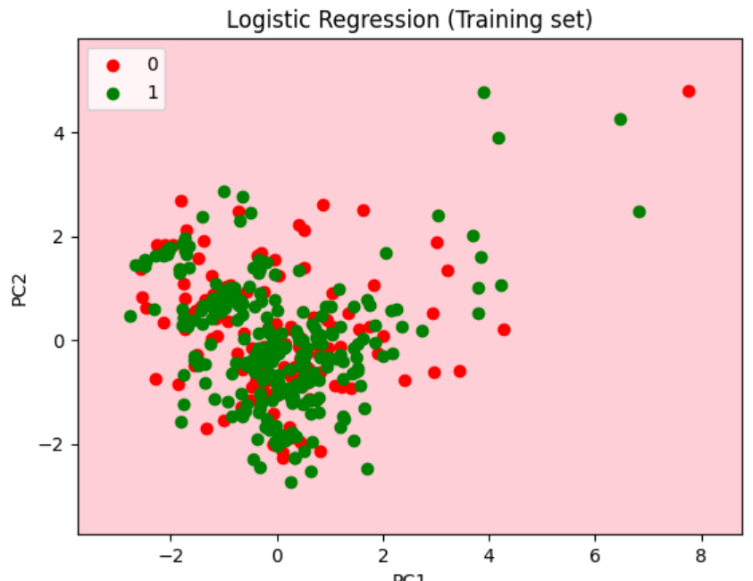 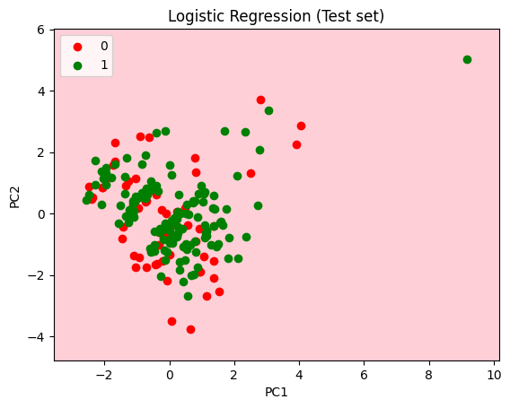

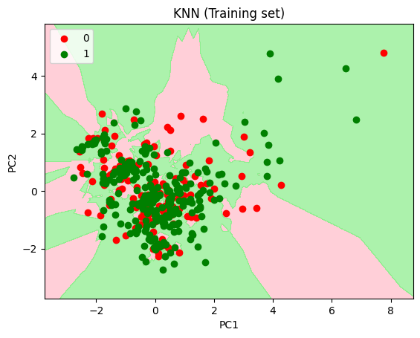 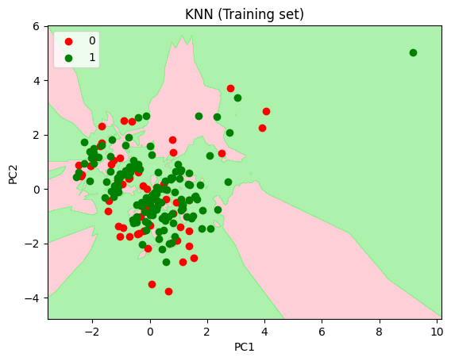

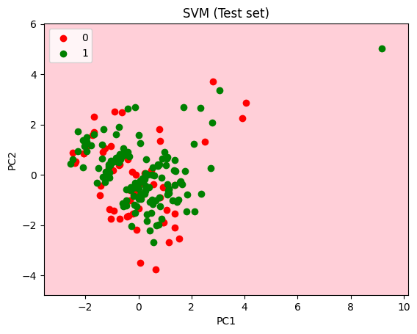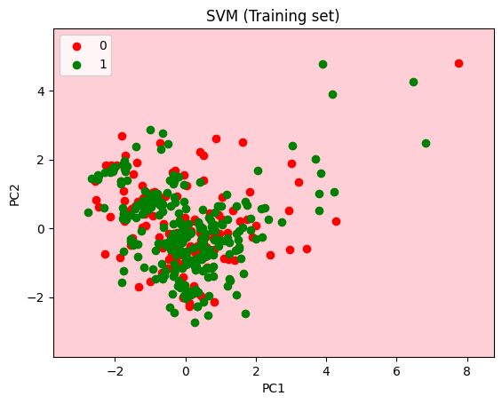

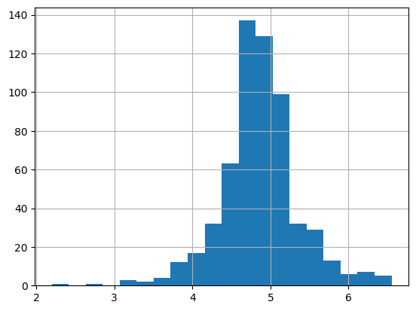 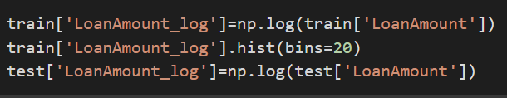

**CONCLUSION:**

In conclusion, loan prediction models are a valuable tool for banks and financial institutions to assess the creditworthiness of borrowers and predict the likelihood of loan defaults. By using machine learning algorithms to analyze historical data, these models can make accurate predictions and minimize the risk of losses.

In this project, we have discussed various techniques for building and improving loan prediction models, including data cleaning, feature selection, hyperparameter tuning, and model evaluation. We have also explored additional tasks that can be performed to further improve the model's accuracy and interpretability.

Going forward, loan prediction models will continue to play an important role in the banking and finance industry, as they help to improve the accuracy and efficiency of loan approvals. With ongoing advancements in machine learning and big data analytics, loan prediction models will become even more powerful and customizable, providing personalized loan recommendations based on individual borrowers' financial history and creditworthiness.

**REFRENCES:**

1. Here are some references to papers and articles related to loan prediction models:
2. Li, Y., & Li, L. (2020). Loan prediction based on data mining techniques: A systematic review. Information Processing & Management, 57(6), 102294.
3. Wani, T. A., & Ahmad, J. (2018). Loan default prediction using machine learning techniques. International Journal of Computer Applications, 181(27), 24-28.
4. Akhtar, S., Jaffery, S. Z. A., & Iqbal, S. (2017). Comparative analysis of classification algorithms for loan prediction. International Journal of Computer Applications, 175(2), 34-39.
5. Zhang, X., Jiang, Y., & Chen, Y. (2018). Credit risk prediction using machine learning algorithms: A survey. International Journal of Financial Engineering, 5(02), 1850004.
6. Hossain, M. S., & Rahman, M. A. (2019). Credit scoring models in machine learning: A survey. Journal of Financial Data Science, 1(1), 3-20.
7. Zehra, F., & Raza, B. (2020). Loan default prediction using machine learning: A comprehensive review. Journal of King Saud University-Computer and Information Sciences, 32(1), 105-118.